COURSE PROJECT
Flight Price Prediction using Predictive Analytics

Author: Linh Huynh
Bellevue University
DSC630-T303 Predictive Analytics (2257-1)
Instructor: Andrew Hua
08/10/2025

INTRODUCTION
Flight ticket prices often change due to several factors like timing, flight route, airline, number of stops, and customer demand. For travelers, knowing when prices go up or down helps them choose better flight times. For airlines and travel companies, being able to predict ticket prices can help them set better prices and increase sales. This project will create a model that predicts flight ticket prices using data about different flight details. The final goal is to help airlines and customers make better choices.
This project wants to solve the problem of price prediction for airline tickets. It will use flight data such as airline name, departure and arrival cities, flight time, total stops, flight duration, and other time-related data. The project will use machine learning to look for patterns and train a model that can predict flight prices accurately. This solution is useful for pricing teams in airlines, travel platforms, and budget-conscious travelers.
The learning objectives of this project are to identify the key factors that influence flight prices, compare various prediction models to determine which performs best, gain hands-on experience with model training, and generate actionable insights to support effective pricing strategies.

OVERVIEW OF DATA USED
The dataset used in this project is from Kaggle: the Flight Price Prediction Dataset. It contains many flight records from India, with approximately 10,000 rows of real-world data and 11 columns, including:
- Airline - Name of the airline
- Date_of_Journey - Date of the flight
- Source - Departure airport
- Destination - Arrival airport
- Route - The flight path and any stops
- Dep_Time - Departure time
- Arrival_Time - Time of arrival
- Duration - Total flight duration
- Total_Stops - Number of stops (e.g., for layovers or refueling)
- Additional_Info - Extra details (e.g., meals not included)
- Price - Ticket price
This dataset is useful because it includes many features that affect ticket prices. It contains both numerical and categorical data, which supports different methods of data preparation. Since the data comes from real flights, any model built from it can be applied to real-world situations. It also allows for testing and comparing various prediction models in a clear and effective way.
While the dataset is useful for building predictive models, there are a few risks and ethical concerns to consider. First, the data might contain biases related to specific airlines, routes, or cities, which can lead to unfair predictions. For example, if most of the data comes from low-cost airlines, the model may not perform well for premium airlines. Second, although the dataset appears anonymized, using real-world data always raises concerns about privacy, especially if any personal information was originally included. Finally, there is a risk of misuse. For example, if companies use the model to increase prices unfairly or discriminate between customers. To address these concerns, I must handle the data responsibly, ensure fairness in model training, and be transparent about how the predictions will be used.

METHOD OF ANALYSIS
Python will be used along with libraries such as pandas, scikit-learn, and XGBoost. For data visualization, matplotlib and seaborn will be applied. All steps of the project will be documented in a Jupyter notebook.
This project will use three models. First, Linear Regression, a simple method that provides basic results and helps in understanding the data. Second, Random Forest Regression, a more powerful model that works well with complex data and identifies the most important features. Finally, XGBoost Regression, a modern and fast model that often delivers higher accuracy for structured data.
The performance of the models will be evaluated using three key metrics: Mean Absolute Error (MAE), Root Mean Squared Error (RMSE), and R-squared (R²). MAE measures the average size of the prediction errors, showing how far, on average, the predicted values are from the actual prices. RMSE gives more weight to larger errors, making it useful for detecting cases where the model makes big mistakes. R² indicates how much of the variation in the actual prices is explained by the model, with values closer to 1 showing a better fit. Together, these metrics provide a clear and balanced view of the models’ accuracy and reliability.
1.Data Preparation for Model Building
The process of preparing the flight price dataset involved several critical data cleaning and transformation steps to ensure the dataset was suitable for machine learning modeling. Below is a recap of the full preparation process:
1.1 Loading and Initial EDA
The dataset was loaded using pandas, and an initial inspection was conducted to understand the shape, structure, and completeness of the data. This included examining the first few rows using .head()
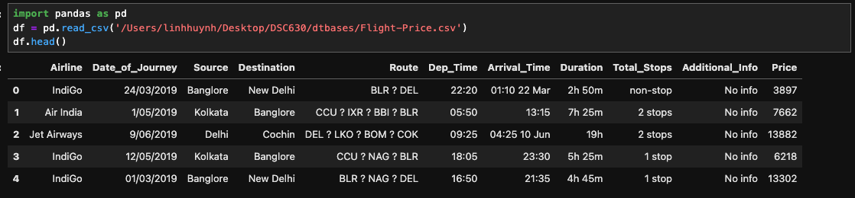
Dataset dimensions via .shape

Data types and presence of null values using .info() and .isnull().sum()
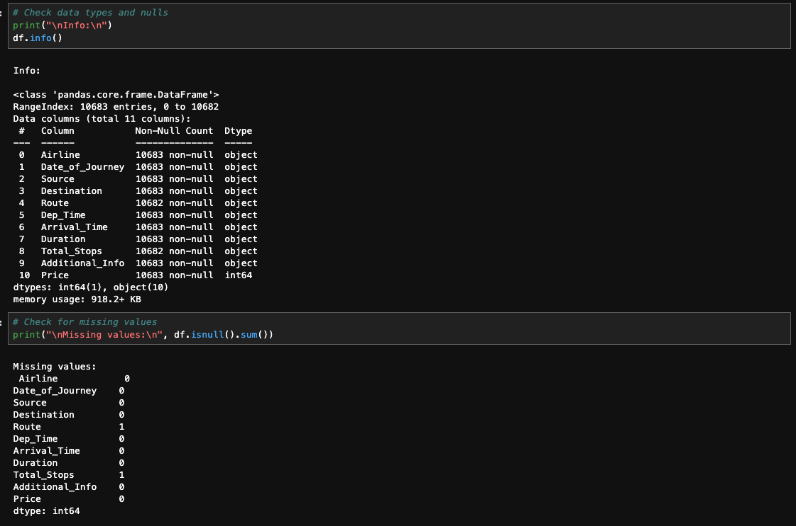

1.2. Handling Missing and Infinite Values
Missing data was identified in several key columns such as Route, Total_Stops. Since the missing entries were limited, the decision was made to drop all rows with null values using:
Infinite values in Python (like np.inf and -np.inf) can result from operations like dividing by zero or log of non-positive numbers, and they can disrupt plots, machine learning models, and statistical calculations. Therefore, cleaning is necessary, by replacing them with NaN and then dropping them.

1.3. Feature Extraction and Transformation
Several features in the dataset were in string format and required transformation into numerical values for effective modeling.
Duration Field: The Duration column was in a mixed format (e.g., "2h 50m", "5h") and was transformed into a single numeric column representing total minutes. This was achieved through a custom function that parsed and calculated the duration consistently across all rows.
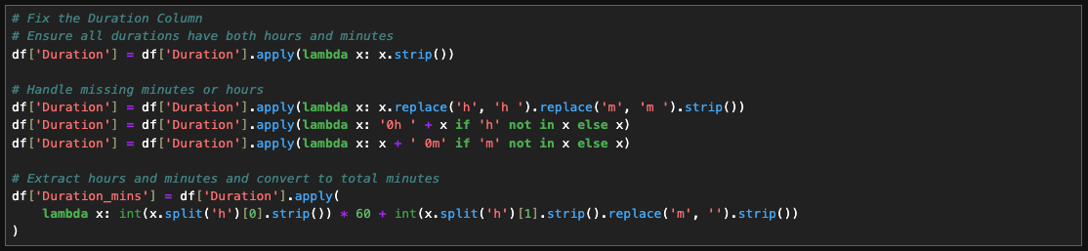
Date and Time Columns: Date_of_Journey was converted into two new numerical features: Journey_day, Journey_Weekday (Monday =0, Sunday=6) and Journey_month. Dep_Time and Arrival_Time were split into hour and minute components. All original date and time columns were dropped after extraction.
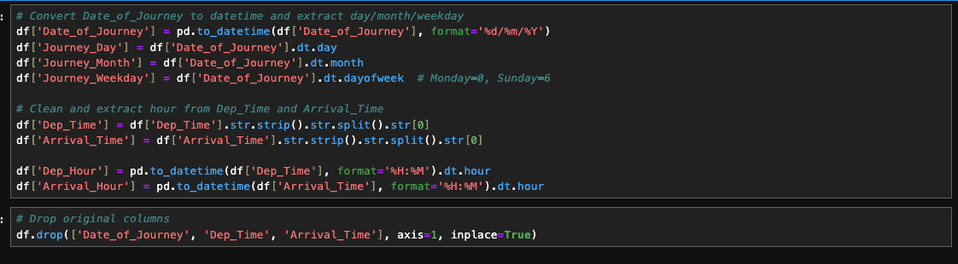

1.4. Removing Redundant and Low-Value Features
The following features were removed: Route - Redundant with Total_Stops and too detailed for the model. Additional_Info - Contained mostly "No Info" entries, offering limited predictive value.

1.5. Encoding Categorical Variables
Categorical features such as Airline, Source, Destination, and Total_Stops were transformed using one-hot encoding to prepare them for machine learning algorithms that require numeric input. This ensured all features in the dataset were numeric and machine-readable.
After completing all cleaning and transformation steps, the dataset consisted of only relevant and clean features, with all variables converted to numeric types, no remaining missing values, and fully prepared for feature scaling and model training.

1.6. Exploratory Data Visualization
Before building predictive models, visual exploration was performed to better understand the structure, distribution, and relationships within the dataset. A series of visualizations were used to identify key patterns, detect outliers, and guide data cleaning and feature engineering decisions. These plots provided insights into how various factors such as airline, number of stops, flight duration, and departure times influence flight pricing. The visual analysis also helped shape which features were retained or transformed in preparation for model training.
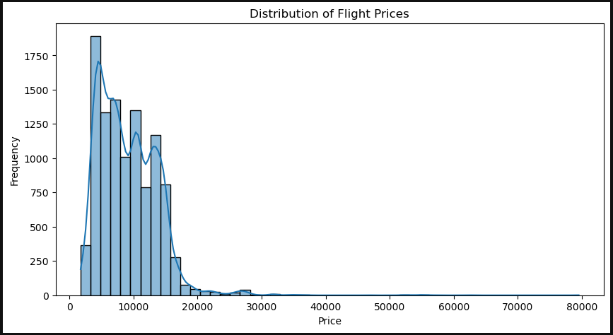
The flight price distribution is right-skewed, with most prices between 2,000 and 15,000, and a few very high outliers above 30,000.
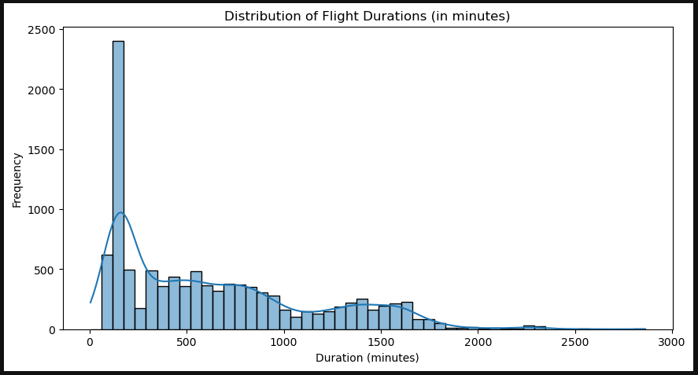
The flight duration distribution is right-skewed, with most flights lasting under 500 minutes and a few long flights over 2000 minutes acting as outliers.
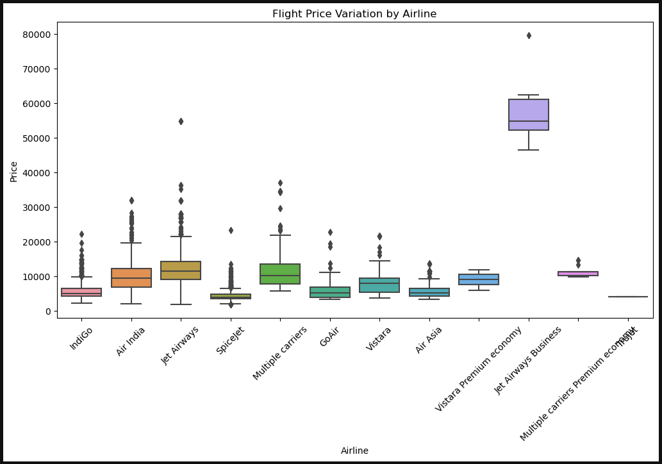
Budget airlines like IndiGo and SpiceJet offer the lowest prices, while Jet Airways Business is the most expensive, with premium classes showing stable prices and regular classes having more variation.
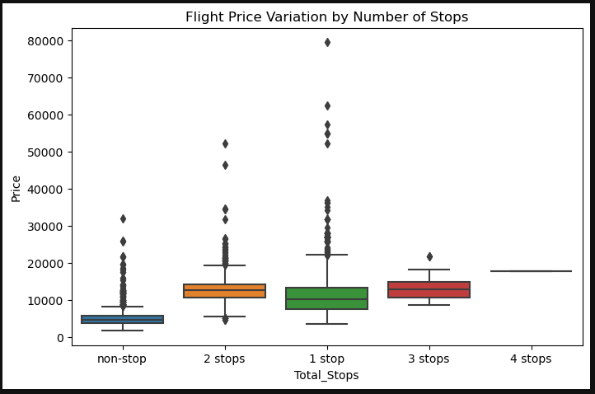
Flights with 1 or 2 stops generally cost more than non-stop ones, while 4-stop flights have fixed high prices, and 3-stop flights show less variation but are also pricey.
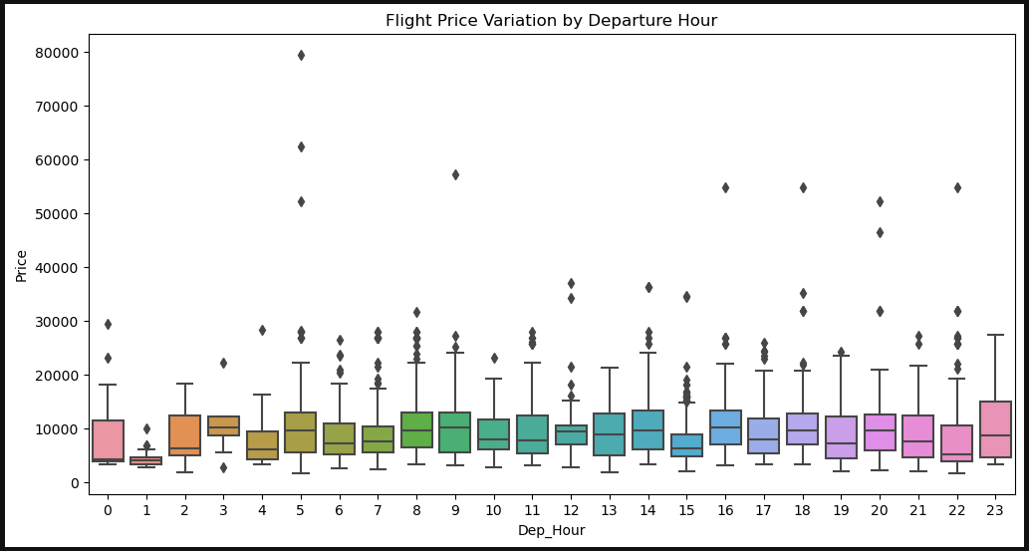
Flight prices are generally higher during early morning (0–2 AM) and late-night (11 PM) departures, while midday to evening hours (10 AM–8 PM) show more stable and moderate pricing.
The charts show useful information about flight prices and travel patterns. Some airlines, like Jet Airways Business, have very high prices. Most flight prices are between ₹2,000 and ₹15,000, and most flights are less than 500 minutes long. Prices go up when the flight date is close. Flights with more stops usually cost more, but in this data, non-stop flights are cheaper, maybe because of cheaper airlines or economy class. Flights in the evening or at night are more expensive than morning or afternoon. Business class tickets cost more than economy class. Prices also change depending on the route. Overall, this information is helpful and shows that I can now start building a model to predict flight prices.

1.7. Final check before modeling
A final check before modeling is crucial to make sure the dataset is clean, complete, and ready for machine learning algorithms.
Train-Test Split: The dataset was first split into training and testing sets using an 80/20 ratio. This allowed the models to be evaluated on unseen data: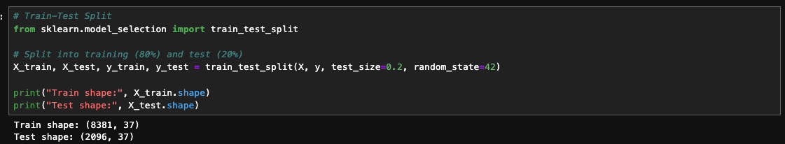
Drop String columns: The columns 'Route' and 'Duration' were dropped because they are string-type and not directly usable in model training; their information was either redundant or already captured in engineered numerical. This step ensures the final dataset is fully numeric and compatible with machine learning models.
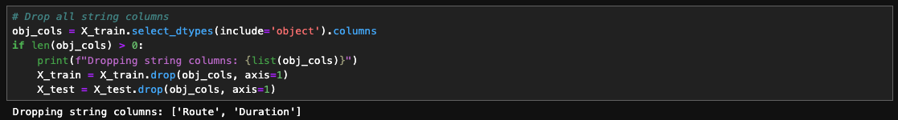
Feature Scaling: Since many machine learning models are sensitive to feature scales, numerical variables were standardized using StandardScaler
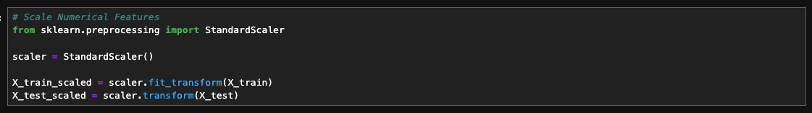

2.Models Building and Evaluation
To predict flight prices, multiple regression models were trained and evaluated using standard performance metrics. The steps followed are outlined below.

2.1. Linear Regression
A baseline linear regression model was trained and evaluated:
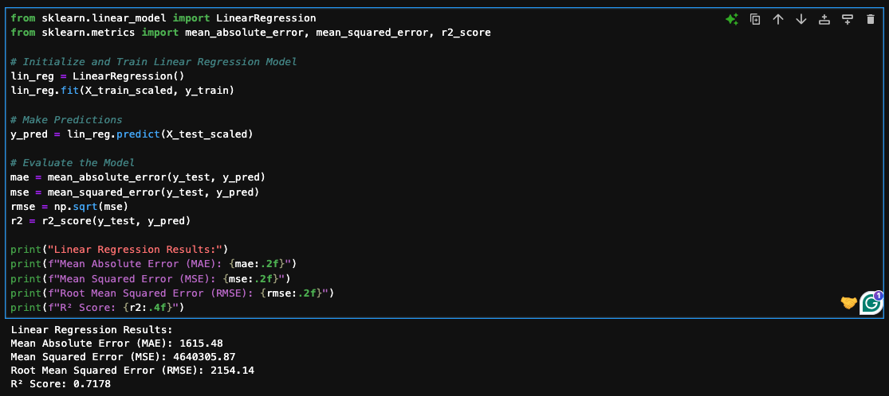
MAE (1615): On average, the model’s predictions are 1,615 off from the actual price.
RMSE (2154): Larger errors are penalized more, typical errors are about 2,154.
R² Score (0.718): About 72% of the variation in flight prices is explained by the model. An R² of 0.72 is strong for this kind of dataset (flight prices are influenced by many factors).

2.2. Random Forest Regressor
A more advanced tree-based ensemble model, which captures non-linear interactions:
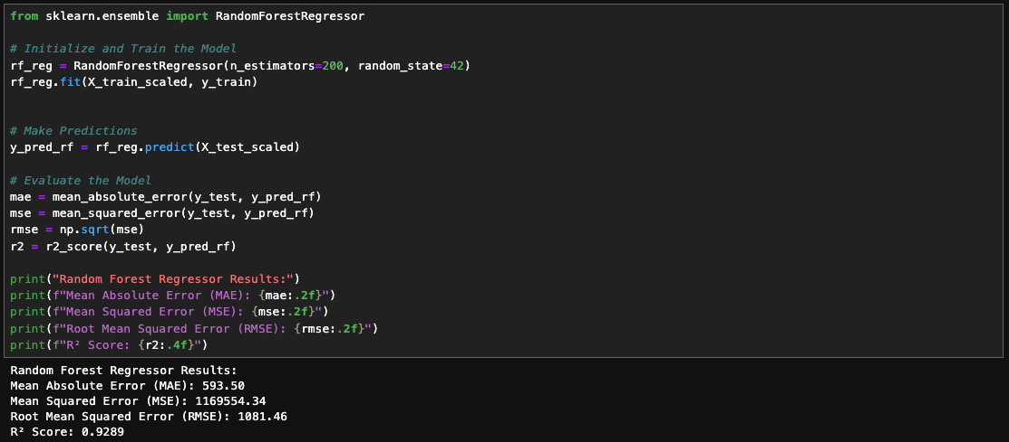
MAE (593): much lower than Linear Regression (1,615)
RMSE (1,081): typical error size cut by ~50%
R² Score (0.93): explains 93% of price variation (better than Linear Regression's 72%)
Random Forest performs much better than Linear Regression. Errors are smaller. Model fits data more accurately.

2.3. XGBoost Regressor
A high-performance gradient boosting model was also tested:
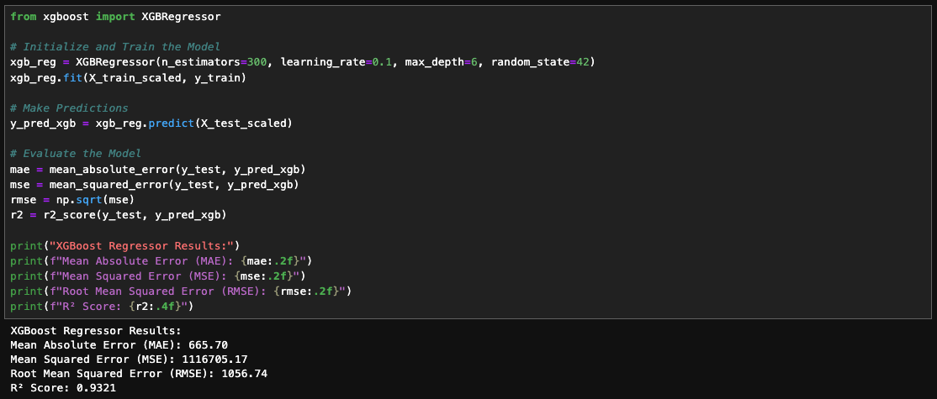
MAE (666): slightly higher than Random Forest’s 593
RMSE (1,057): slightly better than Random Forest’s 1,081
R² Score (0.932): almost the same as Random Forest (0.929)
Both perform very well, but XGBoost has a slight edge on R² and RMSE, while Random Forest wins on MAE.

RESULTS AND FINDINGS
The flight price dataset underwent thorough cleaning and transformation to ensure it was fully suitable for machine learning modeling. After removing missing and infinite values, converting categorical variables into numeric form, extracting useful date and time features, and standardizing scales, the dataset was ready for predictive modeling. Exploratory visualizations revealed that most flight prices fell between ₹2,000 and ₹15,000, with a few expensive outliers. Shorter flights under 500 minutes were more common, while prices tended to rise for premium airlines, flights with more stops, and certain departure times such as early morning or late night. Interestingly, in this dataset, non-stop flights were often cheaper, likely due to budget carriers or economy class options dominating that category.
Three regression models were trained and evaluated using Mean Absolute Error (MAE), Root Mean Squared Error (RMSE), and R² scores.
The first model, Linear Regression, had the weakest performance. It gave the lowest R² score (0.718), meaning it did not explain much of the variation in ticket prices. It also had the highest RMSE (2,154), which shows that the prediction errors were large. This model is simple, but it could not handle the complexity of the data very well.
The second model, Random Forest Regressor, performed much better. It gave a high R² score of 0.929, meaning it explained a large part of the variation in the target. The RMSE dropped to 1,081, and the MAE was 593, showing that this model predicted prices much more accurately. Random Forest is good at finding non-linear patterns and works well with many features, which helped in this case.
The third model, XGBoost Regressor, gave the best results overall. It had the highest R² score (0.932), slightly better than Random Forest. It also had the lowest RMSE (1,057), which means the average prediction errors were the smallest. Although the MAE was a little higher (666) than Random Forest, the overall performance was slightly better.
Based on this comparison, the XGBoost Regressor is the best model for this problem. It had the best balance between accuracy and error size. I recommend using XGBoost as the final model for predicting flight prices. It gives strong, reliable results and would perform well if used in a real-world application. However, Random Forest is also a strong alternative, especially if simpler tuning or faster training time is needed.
Overall, tree-based ensemble models outperformed Linear Regression by a wide margin, with Random Forest and XGBoost both delivering highly accurate predictions. These results indicate that flight prices are influenced by a mix of linear and complex non-linear factors, and advanced ensemble methods are best suited for modeling them.

CONCLUSION
This predictive analytic project successfully demonstrated how careful data preparation, feature engineering, and model selection can lead to highly accurate flight price predictions. The analysis revealed clear pricing patterns, such as higher fares for premium airlines, longer flights, certain departure times, and routes with multiple stops, while budget carriers often offered cheaper non-stop options. Model evaluation showed that while Linear Regression provided a reasonable baseline, tree-based ensemble methods, particularly Random Forest and XGBoost, captured the complex relationships in the data far more effectively, achieving over 93% accuracy (R²) and significantly reducing prediction errors. These findings highlight the value of using advanced machine learning techniques for price forecasting, and they provide a strong foundation for practical applications such as dynamic pricing tools, travel cost estimators, and customer advisory systems.
To improve this project, I could add more features such as seasonal trends, holidays, competitor pricing, and booking class details to enhance prediction accuracy. Addressing imbalanced data is also important; if certain airlines or routes dominate the dataset, techniques to balance the data would help reduce bias. Additionally, advanced feature engineering, like creating variables for time to departure, day of the week effects, or interactions between features, could help capture deeper patterns and improve model performance.

REFERENCE
Imran, M. B. (2021). Flight price prediction dataset. Kaggle. https://www.kaggle.com/datasets/muhammadbinimran/flight-price-prediction
Khare, A. D. (2022). Diabetes dataset. Kaggle. https://www.kaggle.com/datasets/akshaydattatraykhare/diabetes-dataset
Siegel, E. (2016). Predictive analytics: The power to predict who will click, buy, lie, or die (Revised and updated ed.). Wiley.
Abbott, D. (2014). Applied predictive analytics: Principles and techniques for the professional data analyst. Wiley.
Albon, C., & Gallatin, K. (2023). Machine learning with Python cookbook: Practical solutions from preprocessing to deep learning (2nd ed.). O’Reilly Media.
McKinney, W. (2022). Python for data analysis: Data wrangling with pandas, NumPy, and Jupyter (3rd ed.). O’Reilly Media.
Analytics Vidhya. (2022, January 20). Flight fare prediction using machine learning. Analytics Vidhya. https://www.analyticsvidhya.com/blog/2022/01/flight-fare-prediction-using-machine-learning/

